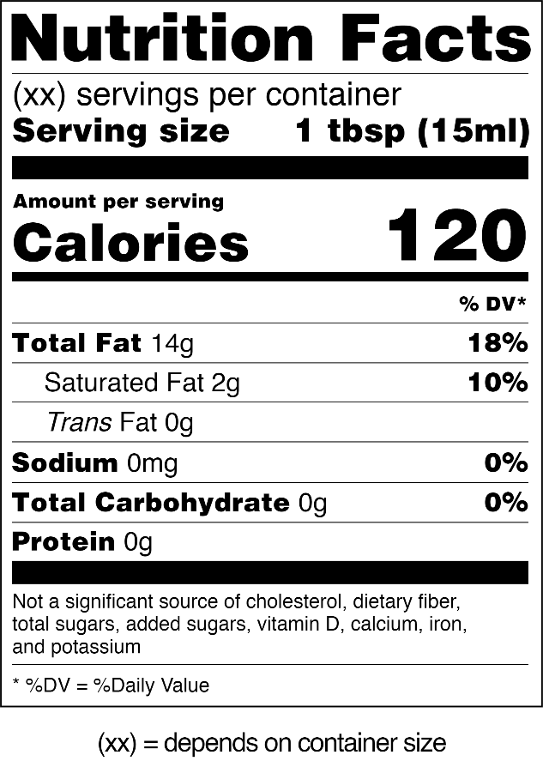
*Extra Virgin Olive Oil

