Raw Unfiltered Organic Apple Cider Vinegar
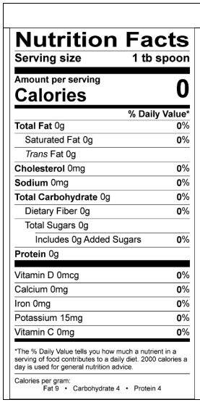
Ingredients: Unfiltered unpasteurized organic apple cider vinegar

