Ultra Premium
Denissimo Balsamico
Certified 1.36+ Density

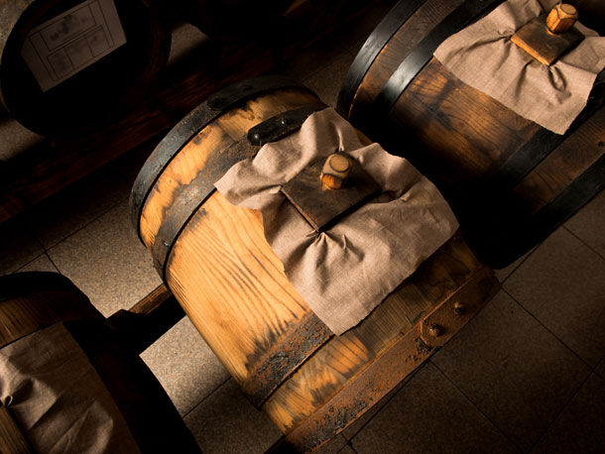

Our Denissimo is made from Trebbiano grape must which is naturally caramelized and cooked down to an even greater extent, and aged for EVEN longer in the traditional “Batteria” of Modena. Our exclusive “Denissimo” contains less than 1% barrel aged Italian red wine vinegar for pro-biotic effect, and slowly ages in five different casks comprised of mulberry, ash, oak, juniper, and cherry wood. This exquisite and exceedingly rare 1.36 density balsamic is extremely complex boasting flavor notes of cherry wood, dried fruits, raisins, figs, along with hints of dark chocolate and malt. Serve with your finest cheese plate, drizzle over melon or berries, use as a finishing glaze for roasted meats or poultry, adorn your grilled vegetables, make your desserts swoon. There isn’t any culinary application in which this balsamic won’t shine.
Product of Modena, Italy

All Natural,
No artificial flavors, no added sugar, no caramel color or additional ingredients

