Jalapeno White Balsamic
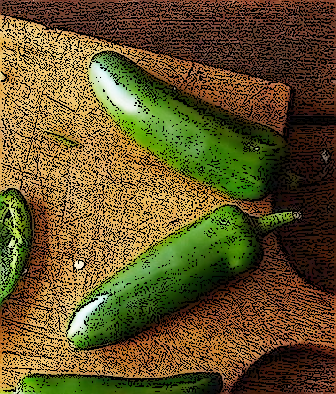
A little sweet with a pleasing amount of heat acidity – Use this to add a spicy kick to your marinades and dressings. Splash a little into ceviche, salsa or add to homemade BBQ sauce! Lovely tossed with grilled vegetables and brushed onto poultry. Pairs well with lemon olive oil, lime olive oil, garlic olive oil, blood orange olive oil, UP olive oil, Baklouti olive oil, and smoked olive oil.

