**MCH490 Umeboshi Plum**

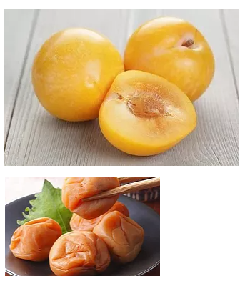

If you take a hint of apricot, combine it with the floral notes of golden-ripe Japanese plums, and the luscious, sweet-tart characteristics of our aged white balsamic from Modena Italy. It pairs well with the Persian Lime Olive Oil, Lemon Olive Oil, Garlic Olive Oil, Toasted Sesame Oil, Orange Olive Oil, and Basil Olive Oil.

​

​Ingredients: Grape must, white wine vinegar, natural flavors, naturally occurring sulfites.

