Raw Unfiltered
Organic Apple Cider Vinegar
MCH090
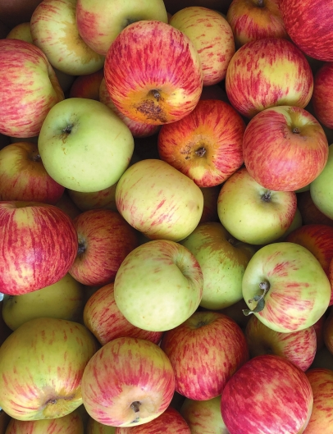
Our lovely, raw, unfiltered, Organic Apple Cider Vinegar comes from small batches made right here in Northern California’s Apple Country. It is rich in phenols and contains the “mother of vinegar” which contributes to its cloudy nature and well touted benefit.
While many consume apple cider vinegar mixed with water or by itself, it does make a lovely, sharp addition to pickles, ceviche, dressings, and marinades.
It pairs well with any extra virgin olive oil in our collection! Please explore the endless options.

