IOO513 Ginger & Black Garlic Infused Olive Oil
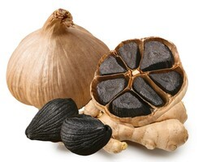

Our Ginger & Black Garlic Infused Olive Oil is Out of this World! Earthy, savory, and sweet. Great for bread dipping, incorporating into dressings, or rubbing onto chicken or fish for roasting.

Parings: Toasted Sesame Oil, Umeboshi Plum White Balsamic Vinegar, Tangerine Dark Balsamic Vinegar.

Black garlic has been around for many, many years. It is regular garlic that has been aged and caramelized. A culinary staple for chefs and epicureans. It is savory yet sweet.

