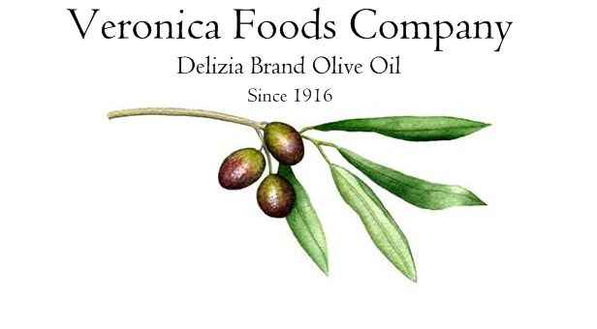

Now you can have your butter and eat it too!

Our butter flavored extra virgin olive oil only contains 100% natural flavor and that is all. As a matter of fact, there are no chemicals, artificial, synthetic ingredients, dairy, or wheat used in any of our flavored products. All of our oil infusions are natural and come from plant based essential oils. The ingredient statement for our butter flavored olive oil reads: certified extra virgin olive oil, organic compatible natural flavor. The nutritional information for this oil is identical to a standard extra virgin olive oil nutritional statement. There are no allergens associated with our product as its dairy free. We do offer allergen statements for all of our products and encourage you to keep a copy on hand to address questions regarding allergens.

Our butter olive oil brings together the best of both worlds with all the health benefits and phenols of extra virgin olive oil and the rich 100% natural flavor of butter. We suggest using our natural butter extra virgin olive oil on pancakes, in baking to replace butter in recipes, drizzled over mashed potatoes, popcorn, and pasta or simply to dip bread in.

