MCH 389 Champagne Vinegar
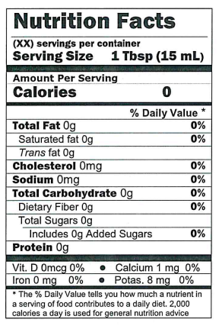
Ingredients: Wine vinegar, grape must, caramel color, natural flavors, naturally occurring sulfites.

