Wild Fernleaf
Dill Olive Oil

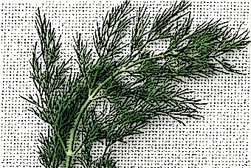

Made with Certified Ultra Premium Extra Virgin Olive Oil, this highly aromatic, vibrant infused olive oil is a must-have Mediterranean culinary staple. We recommend using it in dressings, marinades, with cucumbers, chopped salads, drizzled over spinach, fish, green beans, poultry, meat, in soups, egg dishes, creamy sauces, aioli or olive oil based mayonnaise, for making tartar sauce, roasted potatoes, potato salad, roasted and fresh vegetables, braised white beans, or for baking delectable herb breads and rolls. It pairs beautifully with the Sicilian Lemon White Balsamic, Oregano White Balsamic, Traditional Style Balsamic Condimento, Pomegranate Dark Balsamic Condimento, and Champagne Vinegar to name just a few.

All Natural
No artificial flavors or additional ingredients

