MCH158 Organic Balsamic
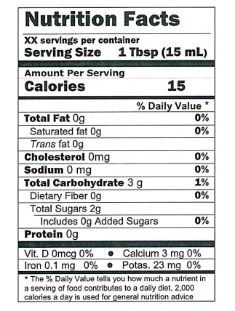
Ingredients: Grape must, wine vinegar, natural flavors, naturally occurring sulfites. No caramel color or additional ingredients.

